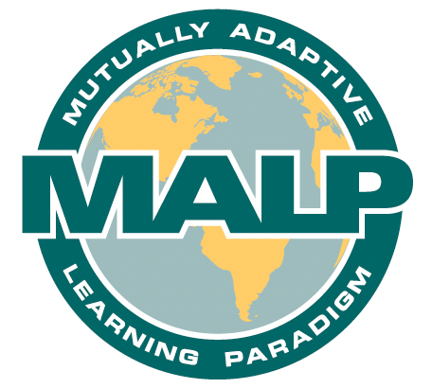
MALP® Teacher Planning Checklist
Mutually Adaptive Learning Paradigm®

Make a Copy​​

A. Accept Conditions for Learning
A1. I am making this lesson/project immediately relevant to my students’ lives.
Explain:
A2. I am helping students develop and maintain interconnectedness with each other.
Explain:

B. Combine Processes for Learning
B1. I am incorporating both shared responsibility and individual accountability.
Explain:

B2. I am scaffolding the written word through oral interaction.
Explain:

C. Target New Activities for Learning
C1. I am developing academic ways of thinking.
Explain:

C2. I am teaching students to engage in decontextualized tasks to demonstrate mastery.
Explain:

C3. I am using familiar language and content as scaffolds.
Explain:

Revised from © DeCapua, A. & Marshall, H.W. (2011). Breaking New Ground: Teaching Students with Limited or Interrupted Formal Education in Secondary Schools, University of Michigan Press, (p.68).
For terms and conditions of use, contact information@malpeducation.com

